2.3 Arc Length & Change of Parameter
Recall: In calculus II you probably were introduced to the formula for the length of a parametric curve in two dimensions. Since the distance formula in three dimensions is very closely related to the distance formula in two dimensions, this formula extends nicely in the 3-dimensional case. However, before we present this formula we introduce some terminology.

Definition: A parameterization is called smooth on an interval I if is continuous and for any t on I. A curve is smooth if it has a smooth parameterization. A smooth curve has no sharp corners or cusps.

Theorem: Suppose that is a smooth vectored-value function for , where the curve is only traversed one time as t goes from a to b then

.

Partial Proof:

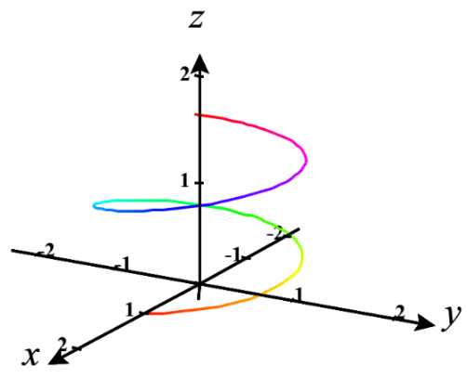
Suppose we have a smooth vector-valued function given by where .

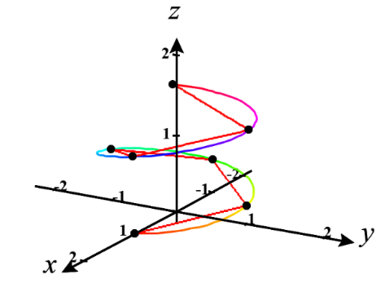
We measure the length of any given line segment by creating a vector between the endpoints, which we will call , and calculating its magnitude.

Therefore, we estimate the total length of the vector function to be .

With a much more complicated argument it can be shown that the FTOC and the MVT can be used to establish that

Therefore,

So, we have

Example 1: Find the length of the curve determined by from the point and .

Definition: Suppose a curve C is given by where where is continuous and C is traversed exactly once as t increases from a to b. We define the arc length function of C to be
for t in .

Note: Intuitively the arc length function of C takes in t and spits out the length of the part of C traversed from a to t.
Remark: By the fundamental theorem of calculus . Therefore, as we will see later in Chapter 5, the arc length integral is sometimes written as .
Example 2: Suppose C is given by where . Find the arc length function of C.

In the past several sections we have communicated curves in 3-space using parametric equations which used a parameter of t that we commonly thought of as representing time. However, it can be helpful to change parameters so that we can measure motion along a curve not just by some value of time. Specifically, it will be helpful to measure motion along a curve in terms of the distance we have travelled from some fixed starting point, that is to say, using arc length.

Definition: Suppose a curve C is given by with where r is a smooth vector-valued function and C is traversed exactly once as t increases from a to b. If from the arc length function for we can solve for t to obtain t as a function of s, then the arc length parameterization of C is .

Steps to Obtaining an Arc Length Parameterization for a Curve:
- Find the arc length function of C, .
- Use to solve for t in terms of s (this may not be possible). Then, you have t as a function of s.
- Simply use composition of functions to obtain your arc length parameterization: .

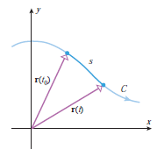
Remark: The power in the arc length parameterization is that if your plug a number like 2 into it, it will spit out a position vector whose terminal point is the point at which a particle which started its movement at the initial point of C is located after it has traveled 2 units along C.

Example 3: Suppose C is given by where .
- Find an arc length parameterization of C.

- Plug into the parameterization you found in (a). Look back in your notes to see why the result that you get is awesome.

